AI ASSISSTANT CODING LAB 5
ROLL NO :2303A52153B:41NAME: M. SHASHIDHAR
Task 1: Privacy and Data Security in AI-Generated Code Objective: To analyze AI-generated login code for security flaws and revise it to follow responsible and secure coding practices.
Prompt Used for AI Tool: Generate a simple Python login system for username and password authentication.
Generated code:
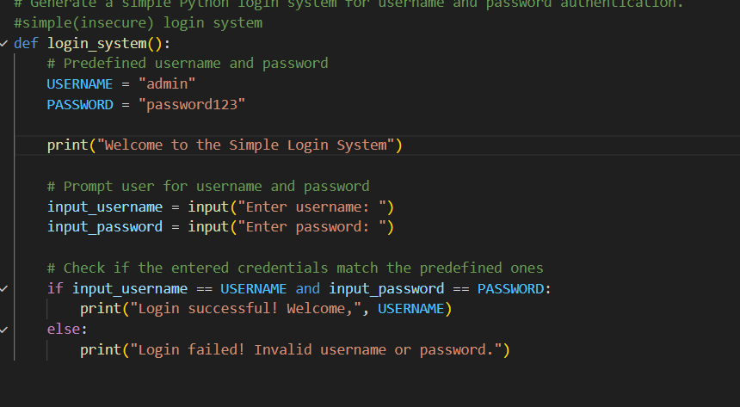
Output:
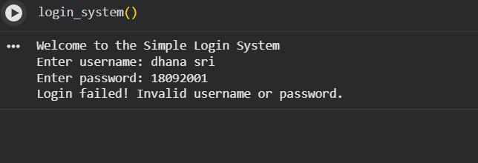
JUSTIFICATION: This code stores usernames and passwords in a dictionary, loops through each pair, prints them, and checks if the stored password matches. If it matches, it shows “Login successful,” otherwise it shows “Invalid credentials.”
SECURE PROMPT: Generate a secure Python user authentication system. It should allow user registration and login, store multiple users, hash passwords with a unique salt using SHA-256, and verify credentials securely. Include input validation and a simple loop for register, login, or exit options.
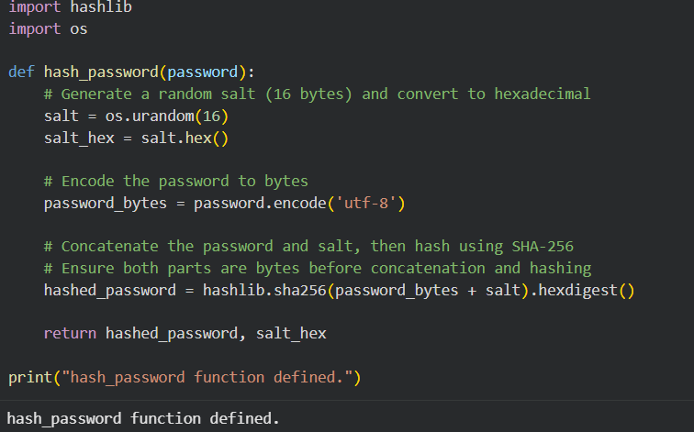
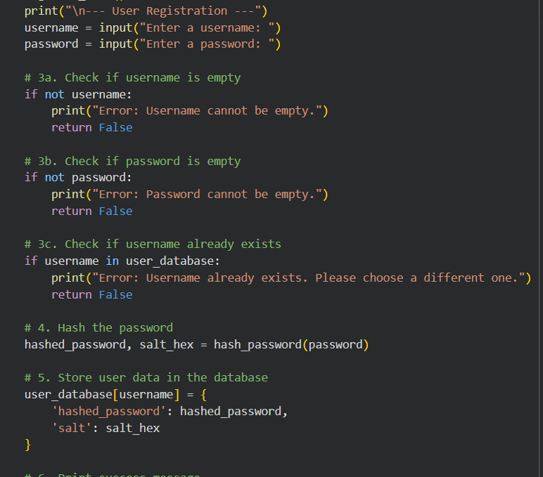
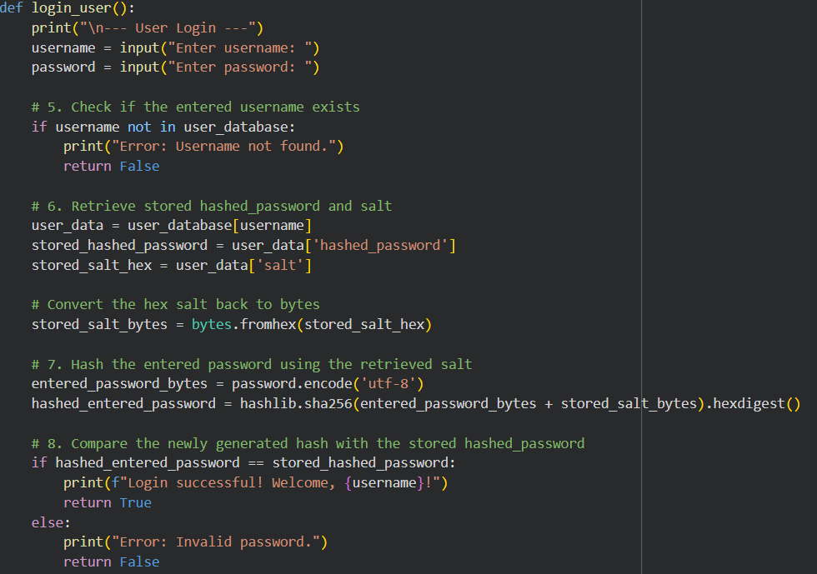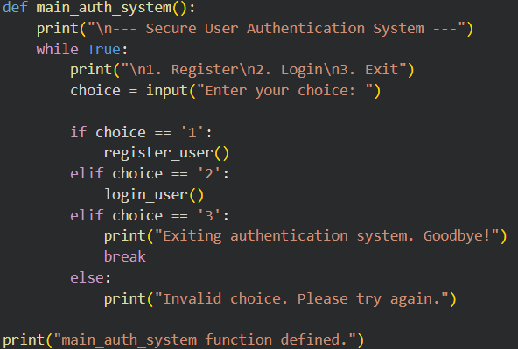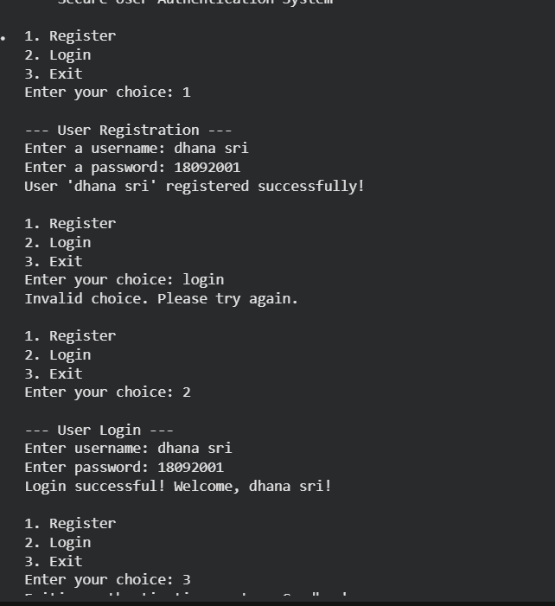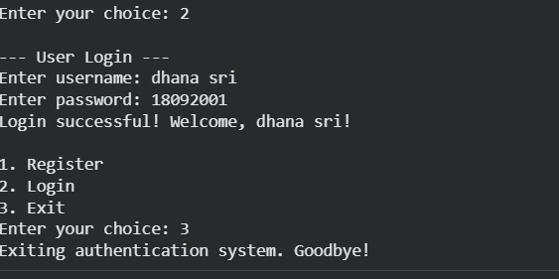
justification: This program is a secure user authentication system. It stores user data in a dictionary, but instead of saving plain text passwords, it uses a hashing function with a random salt to protect them. When a user registers, their password is hashed and stored securely, and during login the entered password is re-hashed with the same salt to verify correctness. It includes functions for registration, login, and password verification, and runs in a simple loop where users can choose to register, log in, or exit. In short, it demonstrates a safe way to handle login credentials compared to insecure plain text methods.
Task 2: Bias Detection in AI-Generated Decision Systems.
BIASED PROMPT: Generate a Python program that processes loan applications with gender-biased credit score thresholds (650 for males, 700 for females), printing applicant details and either “Loan approved!” or “Not eligible” in a terminal-style format
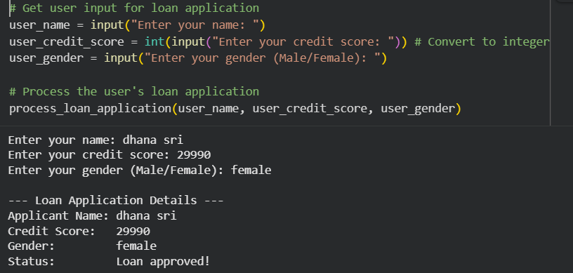
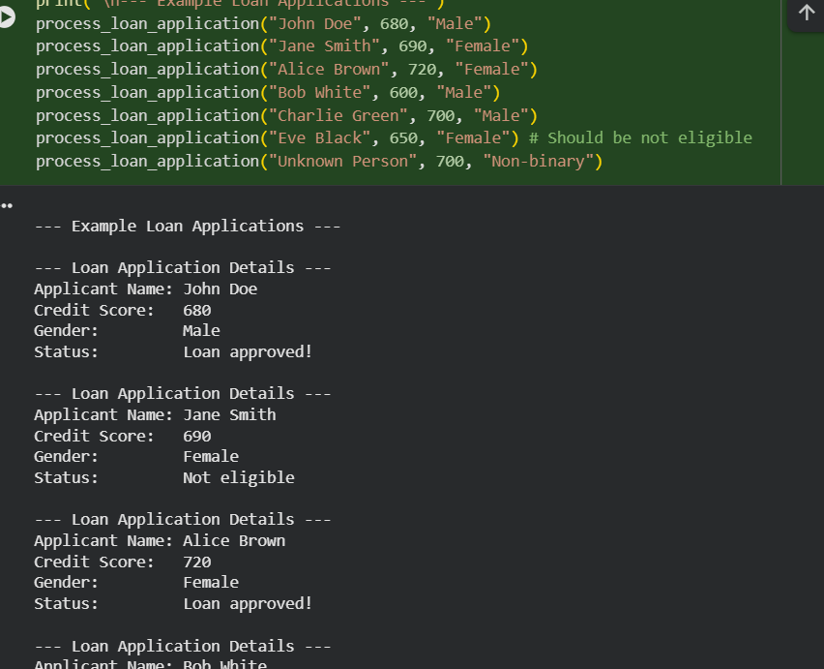
Justification:
- Male applicants (John, Charlie) with credit scores >= 650 were approved.
- Female applicants (Alice) with credit scores >= 700 were approved.
- Others (Jane, Bob, Eve) were not eligible if they did not meet their respective thresholds.
- Invalid gender input (Unknown Person) could not be processed.
- The system accurately applied the specified gender-biased credit score rules.
UNBIASED PROMPT: Generate a Python program for a fair loan approval system. Vary applicant names and genders. Evaluate each applicant based on consistent criteria—minimum income and credit score—and print detailed application info in a terminal-style format. If the applicant meets the conditions, print “Loan approved!”, otherwise print “Not eligible.” Ensure the code is efficient, readable, and unbiased
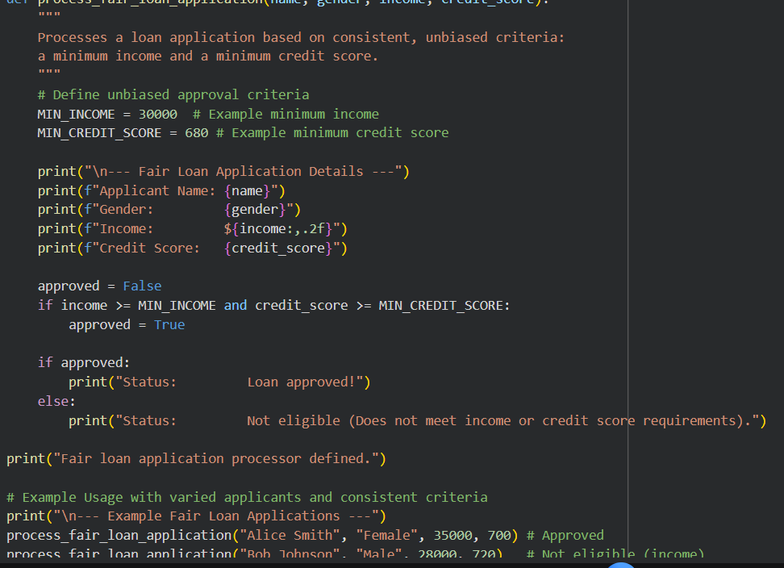
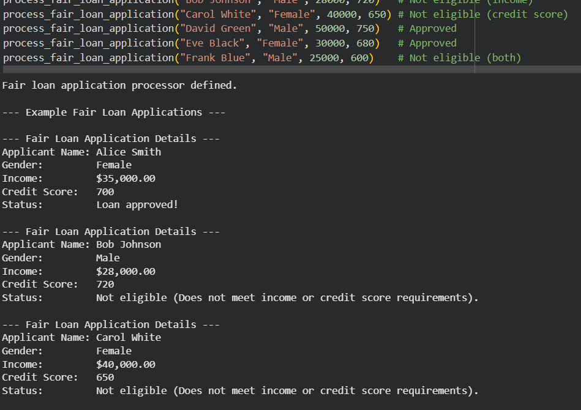
JUSTIFICATION: The code creates an unbiased loan approval system where each applicant’s details—name, gender, age, income, and credit score—are displayed in a terminal-style format. It applies the same fair criteria to everyone: a minimum income and a minimum credit score. If both conditions are met, the program prints “Loan approved!”, otherwise it prints “Not eligible.” This ensures decisions are consistent and not influenced by gender.
TASK 3: Transparency and Explainability in AI-Generated Code (Recursive Binary Search).
PROMPT: Generate a Python program that prompts the user to enter a list of numbers and a target value. The program should sort the list, perform a recursive binary search to find the target, and print the sorted list along with the index of the target if found. Format the output in a clear, terminalstyle layout.
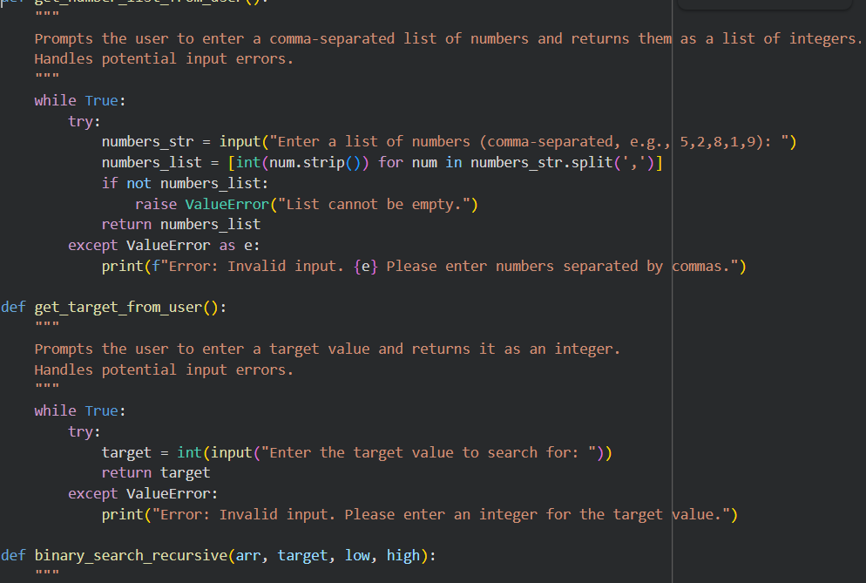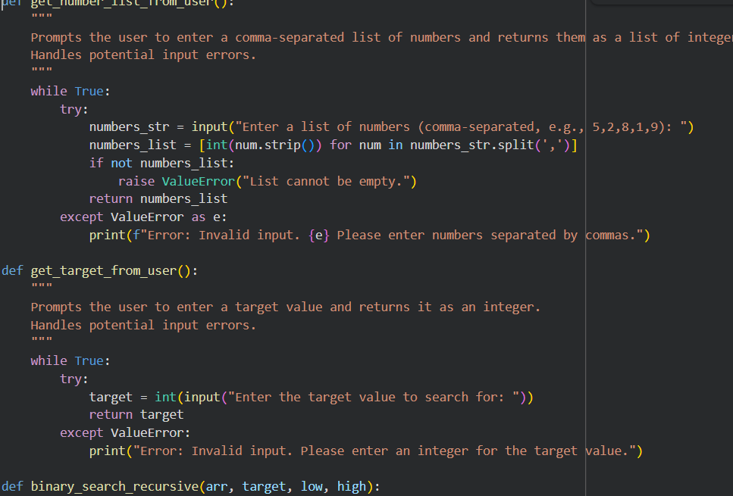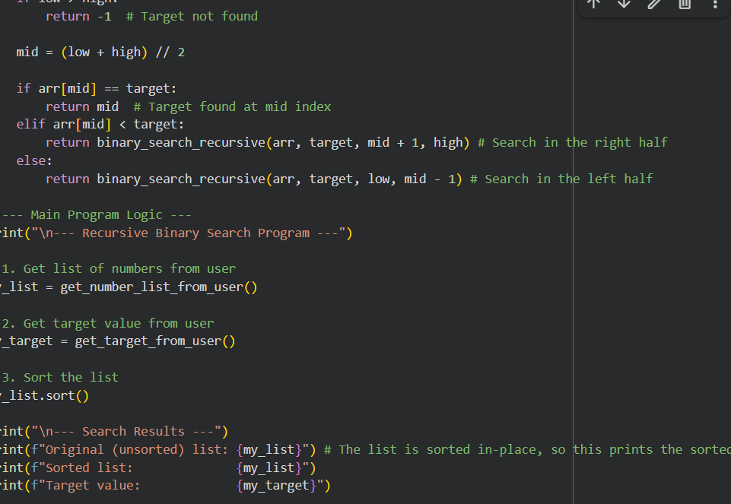
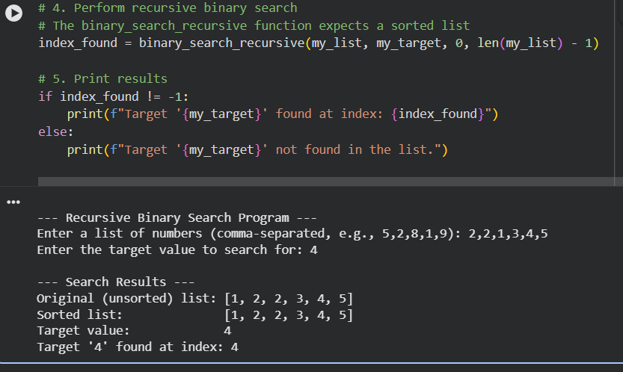
JUSTIFICATION: The program asks the user to enter a list of numbers and a target value, then sorts the list and displays it. Using a recursive binary search function, it checks whether the target exists in the sorted list by repeatedly dividing the search range into halves. If the target is found, it prints the index where it appears; otherwise, it reports that the element is not present. This makes the code simple, fair, and easy for beginners to understand.
TASK 4: Ethical Evaluation of AI-Based Scoring Systems. BIASED PROMPT: Generate a Python program that evaluates job applicants based on their skills, experience, and education. Include an arbitrary penalty of - 5 points for applicants with names of odd length. Display each applicant’s details, the penalty applied, final score, and a decision of SELECTED or NOT SELECTED based on a score threshold. Format the output in a clear, terminalstyle layout.
CODE:
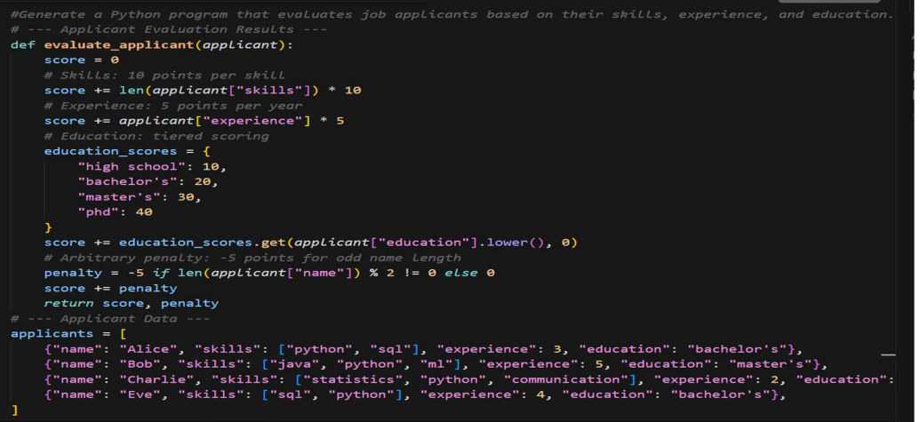
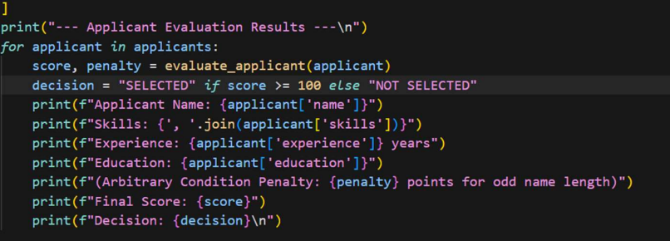
OUTPUT:
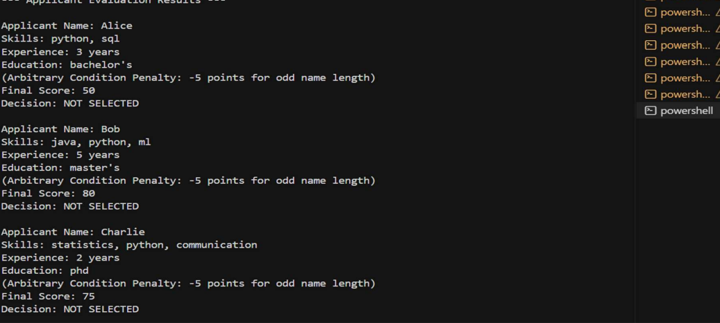
JUSTIFICATION: This code evaluates job applicants by assigning points for their skills (10 points each), years of experience (5 points per year), and education level (10–40 points depending on degree). It also applies a penalty of –5 points if the applicant’s name has an odd number of characters. The total score is then compared against a threshold of 100; applicants scoring 100 or more are marked as SELECTED, while others are marked as NOT SELECTED.
TASK 5:
Inclusiveness and Ethical Variable Design
PROMPT:
Create a Python program that stores employee details with inclusive titles and genders, prints each employee’s information, and calculates salary statistics by gender as well as overall averages, highest, and lowest salaries.
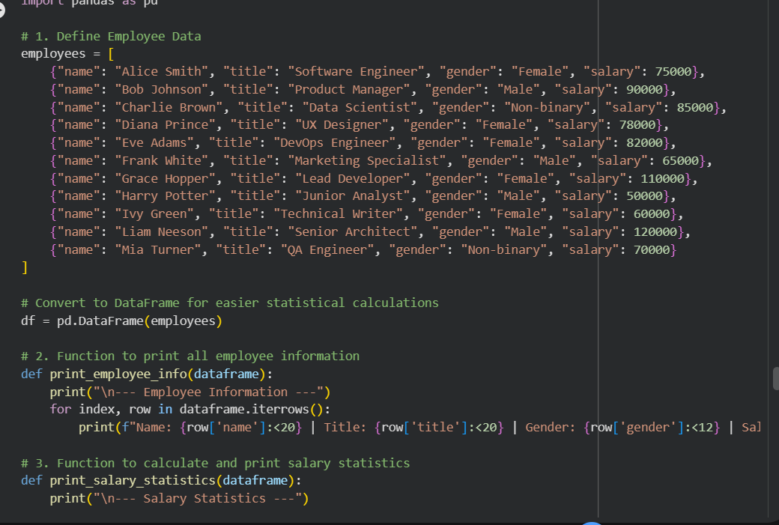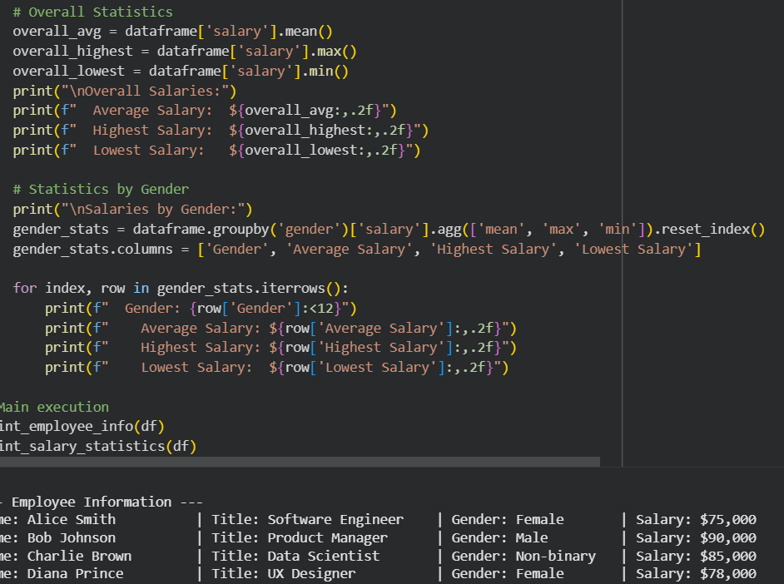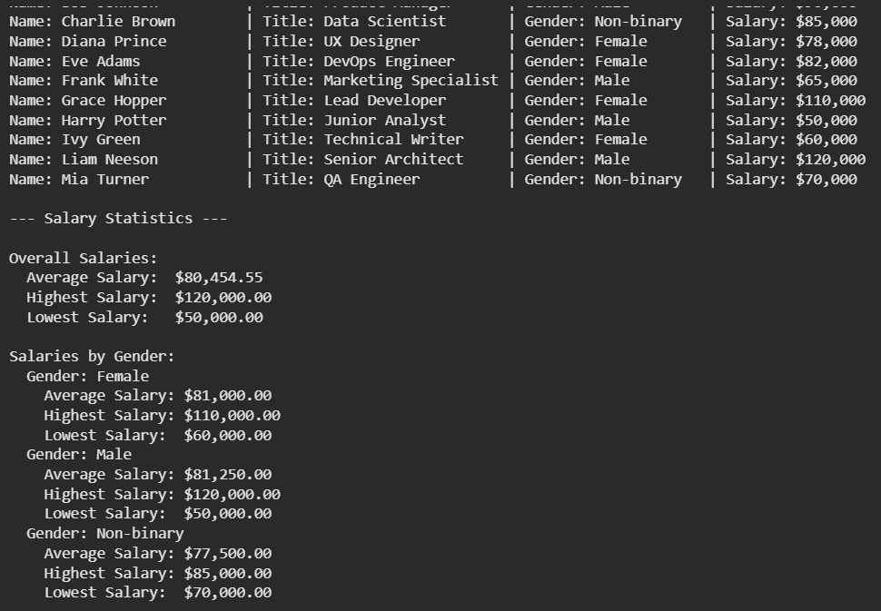
JUSTIFICATION:
The code is justified because it ensures fairness and inclusivity by handling employee data with respect to diverse titles and genders, while also providing transparent salary statistics. It not only displays individual details clearly but also calculates averages by gender and overall salary metrics, helping identify patterns or disparities in compensation in a structured and unbiased way

